TO RECEIVE A QUICK TENDER OFFER, COMPLETE THIS FORM AND SEND TO PANINI S.R.L.:
Panini S.r.l., Attn: Sales Dept. |  | TEL: | +39 0536.94.07.07
Via Taruffi, 70 |  | FAX. | +39 0536.94.37.05
41053 Maranello MO Italia |  | E-MAIL: | mailbox@op-panini.it

NAME: |  |  | DATE:
COMPANY: |  |  | TEL:
ADDRESS: |  |  | FAX:
 |  |  | E-MAIL:

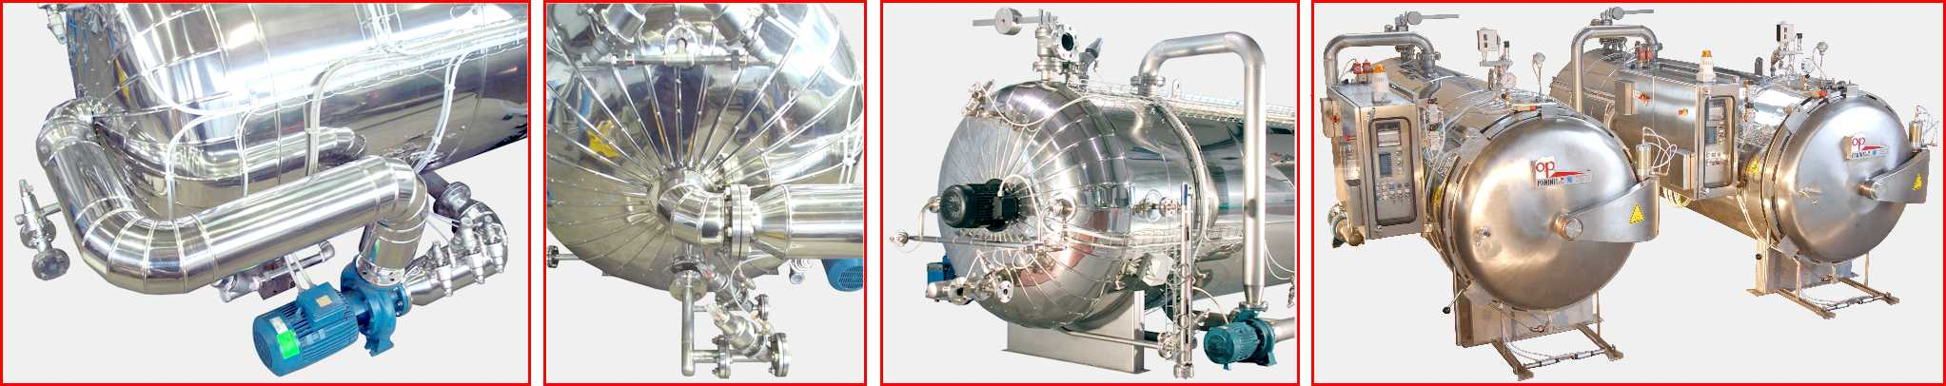

PRODUCT DATA
To choose the basket type and the cycle capacity for each basket, please indicate the product and container type:
FOOD PRODUCT: |  | 
CONTAINER: |  Tin Cans  Glass Jars  Pouches  Ready-Meal Trays
DIMENSIONS: | L = ________ W =________ H = ______ Ø = ______ KG =_______ | 
LAYOUT: |  On Trays  Layer Pads  Stacked (no layer pads)
FILL TYPE: |  In Brine  In Sauce  Vacuum Packed

CYCLE DATA
To calculate the system capacity, and choose the size and number of retorts, please indicate the cycle data. If an item is not indicated, we will assume the default value indicated in parenthesis.
FILLING LINE SPEED: |  | containers / min |  | 
MAX PRODUCT WAIT TIME BEFORE CYCLE: |  | min | (30)
STERILIZATION TIME: |  | min | (20)
TOTAL CYCLE TIME: |  | min | (75)
STERILIZATION TEMPERATURE |  | °C | (121) | 
PRODUCT TEMPERATURE AT START-CYCLE |  | °C | (50)
PRODUCT TEMPERATURE AT END-CYCLE |  | °C | (40)
COOLING WATER TEMPERATURE |  | °C | (16)

RESERVED FOR PANINI SALES DEPT.
REC'D BY: |  |  | DATE REC'D: |  |  | REQUEST N°:
SENT BY: |  |  | DATE SENT: |  |  | OFFER N°:
BASIC FEATURES
Please indicate the basic features required. If no preference is indicated, the first item in each group will be used.
BASIC TYPE: |  |  Static   Rotary | { | Rotary retorts cost more, but reduce cycle time, increase heat penetration and prevent burning of delicate food products.
HEATING: |  |  Direct Steam   Water Spray | { | Direct steam is the simplest and most cost-effective method. Water spray can be less expensive in the case of heating+cooling overpressure.
COOLING: |  |  Water Spray   Flood Cooling | { | Water spray is the most cost-effective method. Flood cooling is used in the most basic retorts for tins cans.
HEAT EXCHANGER: |  |  None   Cooling only   Heating + Cooling | { | A heat exchanger costs more, but allows the use of water with controlled characteristics, reducing the risk of product fouling. The heating+cooling method allows a closed and sterile heating and cooling cycle.
OVERPRESSURE: |  |  Heating + Cooling   Cooling only | { | Overpressure control during heating requires a more advanced retort, but is necessary for glass and plastic containers.
DOOR COUNT: |  |  Single   Double | { | Double doors cost more, but allow simultaneous loading/unloading, or division of sterilized and unsterilised zones for HACCP safety.
DOOR STYLE: |  |  Horizontal   Vertical | { | Horizontal doors are standard. Vertical doors cost more, but allow full automation with transport systems, and reduce floor space.
WORKING PRESSURE: |  |  4 bar   4 bar + Vacuum | { | Vacuum can be used to augment or replace initial venting, and can facilitate in-retort drying with tin cans.

RETORT DIMENSIONS AND FINISHING
Please indicate preferences for retort dimensions. If not indicated, they will be calculated based on the cycle data.
RETORT DIAMETER: |  Calculate Best  1200  1400  1600  1800  2000 | 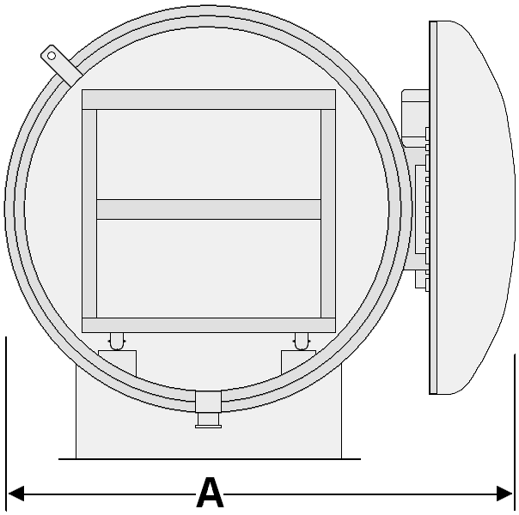
RETORT LENGTH: |  Calculate Best  1000  2000  3000  4000  5000   6000  7000  8000  Custom ______
SHELL MATERIAL: |  Stainless 304  Stainless 316  Mild Steel
SHELL CLADDING: |  Stainless  Aluminum  None
DOOR CLADDING: |  Stainless  Aluminum  None

BASKETS AND TROLLEYS
Please indicate whether to include baskets and trolleys in the offer, and what type. |  | 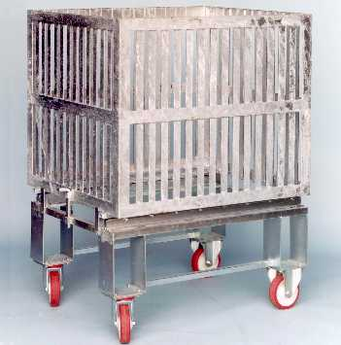
INCLUDE IN OFFER: |  Basket  Layer Pads  Trolley   Use Existing Baskets (attach sketch)
BASKET MATERIAL: |  Stainless Plate  Galvanized Plate  Wire Mesh
BASKET STYLE (TRAYS): |  Side Loading Trays  Stackable Trays
BASKET STYLE (CRATES): |  Fixed Bottom Crate   Moveable Bottom (for automatic / semiautomatic conveyors)   ½ Side Opening (facilitates manual loading)
BASKET TRANSPORT: |  Manual on trolleys  Automatically with transfer system
TROLLEY MATERIAL: |  Stainless Steel  Galvanized Steel  None

CONTROL SYSTEM
Please indicate preferences for retort control systems. The actual control system offered may differ if advanced accessories and features were selected in the previous sections. |  | 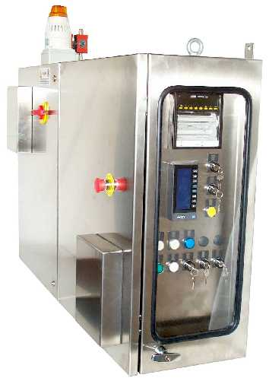
 DEDRA: | Low-cost control panel with mechanical timers and electronic instruments for pressure and temperature control with LED display.
 LAMBDA: | Standard control panel with PLC and LCD graphical display. Memorizes up to 16 recipes with a maximum of 99 segments.
 OMEGA: | Advanced control panel with external Personal Computer control. Features unlimited recipe storage and HACCP statistics for quality control.

